2024 WHMCA Community Cleanup Vendors

List of ACCEPTED and NOT ACCEPTED Items
Please Review Before Arriving at the Hall

LOGO | ORGANIZATION |  | CATEGORY | EXAMPLES OF ACCEPTED ITEMS
 | City of Calgary Waste & Recycling Services and Community Strategies |  | Garbage | - Recreational products  - Lumber from old fences & decks  - Mattresses  - Furniture up to 6’ (desks, chairs, sofas)  - Toilets  - Unique items (garden gnomes, clocks, taxidermy items
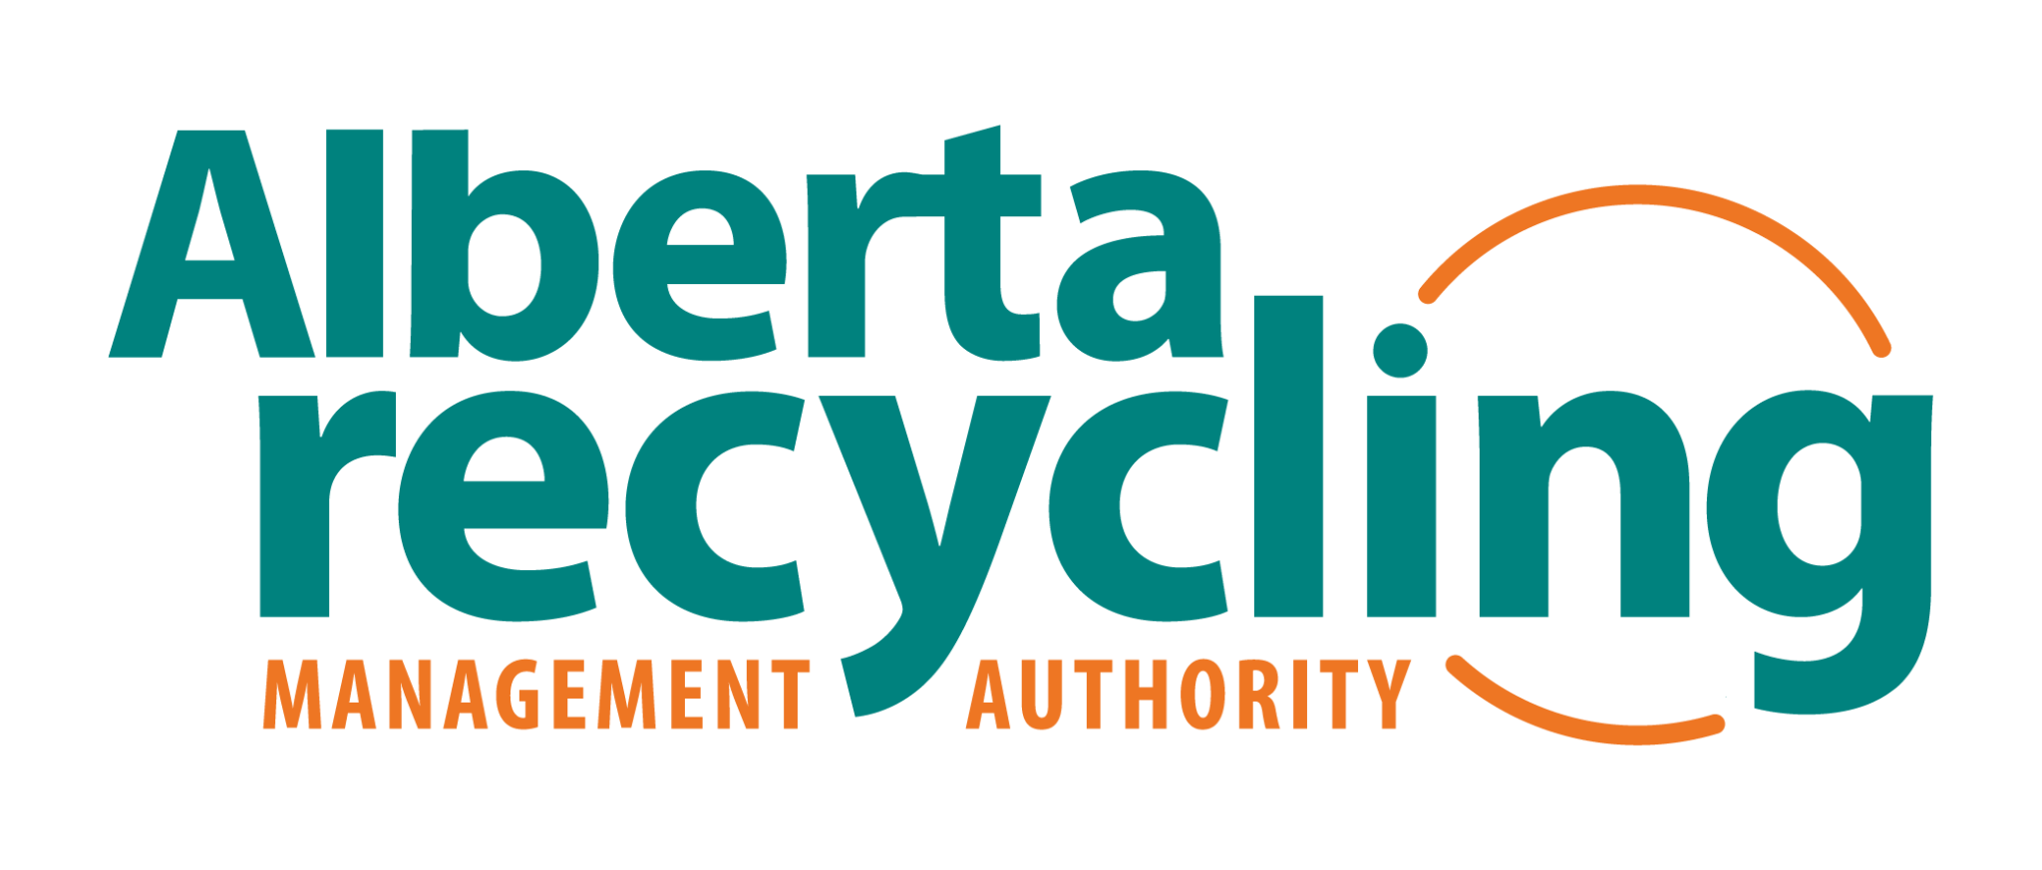 | Technotrash in cooperation with Alberta Recycling Management Authority |  | Electronics Recycling | - Computers  - Eligible batteries (not alkaline)  - Home theatre equipment  - Laptops, e-readers  - Office electronics  - Printers, fax machines, copiers
 | Junk Doctorrr (anything metal) |  | Metal Recycling | - Barbeques (no propane tanks)  - Bikes  - Car parts  - Chains, hardware, pipe & wire  - Fridges & freezers with a fee for Freon disposal  - Lawnmowers w/gas & oil removed  - Bed frames  - Swing sets  - Shelving  - Tables & chairs  - Tin cans  - Tools  - Washers & dryers
 | Calgary Drop-in Centre |  | Gently Used Clothing & Household Goods | - Bed frames, box springs & mattresses (in good condition)  - Clothing  - Couches & other furniture (in good condition)  - Dressers  - Household miscellaneous  - Kitchen tables & chairs  - Linens & towels  - Toasters & other small appliances  - Toothbrushes & travel-size hygiene supplies  - Underwear
 | Action Tyre |  | Car Batteries & Tires | - Tires  - Wheels  - Batteries
 | 6th Calgary Scouts @ St. Barnabas |  | Beverage Containers | - Pop cans  - Juice boxes  - Liquor / beer bottles
NOT ACCEPTED BY CITY GARBAGE TRUCKS OR OTHER VENDORS
- Aerosols | - Large office furniture
- Ammunition or explosives | - Liquids of any kind (cooking oil, gas, paint, chemicals)
- Anti-freeze | - Medical waste, medications
- Asbestos | - Paint, glue, solvents, chemicals
- Bear spray | - Railway ties
- Bio-hazardous waste | - Scrap w/lead, sludge, radioactive, mercury
- Cardboard | - Thermostats & smoke detectors
- Compressed gas cylinders (propane bottles & tanks) | - Yard waste (sod, dirt, etc.)
- Fluorescent light bulbs & fixtures | - Glass of any kind (incl. glass hutches)

THE CITY WILL NOT ACCEPT ORGANICS, RECYCABLES, OR HAZARDOUS WASTE

TAKE RECYCABLES TO 16TH AVE DEPOT
Renfrew Athletic Park (across from Fanning Centre)
16 Ave. & Russet Rd. N.E.

TAKE ORGANICS TO A LANDFILL

TAKE HAZARDOUS WASTE TO A HOUSEHOLD HAZARDOUS WASTE LOCATION
Vista Heights Fire Station No. 4
1991 18 Ave NE

